PROJECT REPORT

**STUDENT DETAILS**

· **Name: AGALYA S**

· **Registration Number:** 24F2008447

· **Course:** BS IN DATA SCIENCE AND APPLICATIONS

· **Institution:** INDIAN INSTITUTE OF MADRAS

**PROJECT OVERVIEW**

The Vehicle Parking Management System is a full-stack web application designed to streamline the process of booking and managing parking slots. It allows users to register, log in, and book available slots, while administrators can manage slots, monitor user activity, and oversee bookings. By replacing traditional manual systems with an automated digital solution, the application reduces human error, enhances operational efficiency, and improves the overall parking experience.

**PROJECT APPROACH**

The project uses a clean and modular architecture:

* Backend: Built with Flask (Python) for handling routes, authentication, and business logic.
* Database: Managed using SQLite3, ensuring lightweight yet robust data storage.
* Frontend: Developed with HTML5 and CSS3, following a dark-themed UI styled with the custom Caviar Dreams font.

The system is designed with role-based access control, clearly separating user and admin functionalities to enhance usability and security.

**FRAMEWORKS AND LIBRARIES USED**

· **Python 3** – Core programming

· **Flask** – Web application framework (routing & logic)

· **SQLite3** – Lightweight relational database

· **HTML5/CSS3** – UI and styling

· **Jinja2** – Templating engine for Flask

· **Caviar Dreams Font** – For custom visual style

· **VS Code** – Development environment

**ER DIAGRAM OF DATABASE**

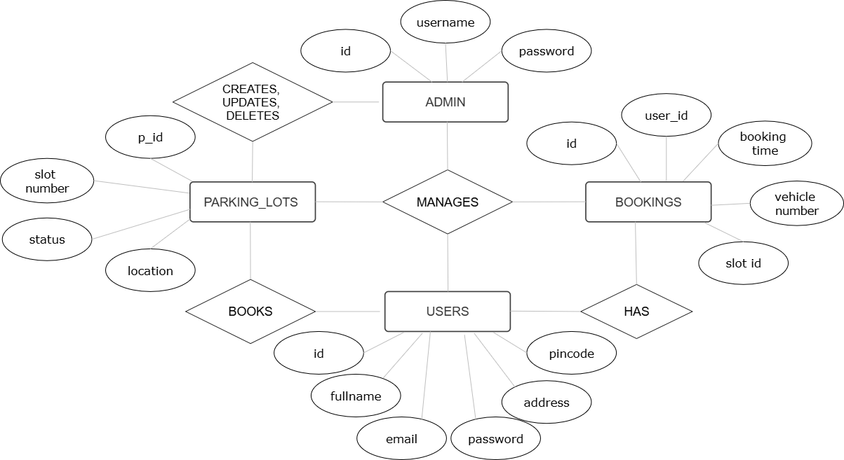

.

**API ROUTES ENDPOINTS**

| **Endpoint** | **Method** | **Description** |
| --- | --- | --- |
| / | GET | Home/Login page |
| /register | GET/POST | Register a new user |
| /login | POST | Authenticate user credentials |
| /logout | GET | Log out current session |
| /user_dashboard | GET | User dashboard view |
| /admin_login | GET/POST | Admin login interface |
| /admin_dashboard | GET | Admin dashboard view |
| /book_slot | POST | Book a parking slot |
| /view_slots | GET | View available slots |
| /manage_slots | GET/POST | Admin: Create/Edit/Delete slots |

**FEATURES IMPLEMENTED**

· Role-based login and access

· User registration and login with validation

· Admin dashboard with slot management

· Parking slot availability tracking

· Responsive UI with frosted glass effect

· Booking system with time and vehicle number logging

· Modular structure and scalable for real-world deployment

**PROJECT PRESENTATION VIDEO**

LINK :

<https://drive.google.com/drive/folders/1ZLEmJ1yqqTZ3pHkCYTzBe0gnZxoQCYKZ?usp=sharing>

**CONCLUSION**

The Vehicle Parking Management System successfully addresses the growing need for efficient, secure, and user-friendly parking solutions in modern urban environments. Designed using the Flask web framework and SQLite, the application provides a structured and scalable platform for managing parking slots, user bookings, and administrative control.

By implementing clearly defined roles for Users and Administrators, the system ensures seamless interaction, with features like real-time slot booking, user authentication, and dashboard insights. The use of a programmatically initialized database ensures easy deployment and maintainability, while the integration of aesthetic design elements (e.g., dark theme, custom fonts, and responsive UI) enhances user experience.

In conclusion, this project not only demonstrates technical proficiency in web development, but also highlights practical problem-solving skills, system security considerations, and user-centric design—making it a robust prototype for smart city parking infrastructure.